Clearing the AudioBase3 database in preparation for re populating the Database

Steve Rance – 14th November 2007-11-14

Clearing the exiting AudioBase3 database

Start the MySQL Query Browser located here…
START->MySQL->MySQL Query Browser.

Fill in the details as below and the password for your database, this may be “dream”.

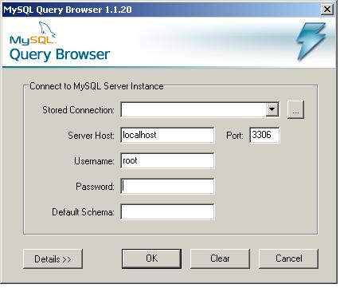

Once you have logged in you should see something like this.

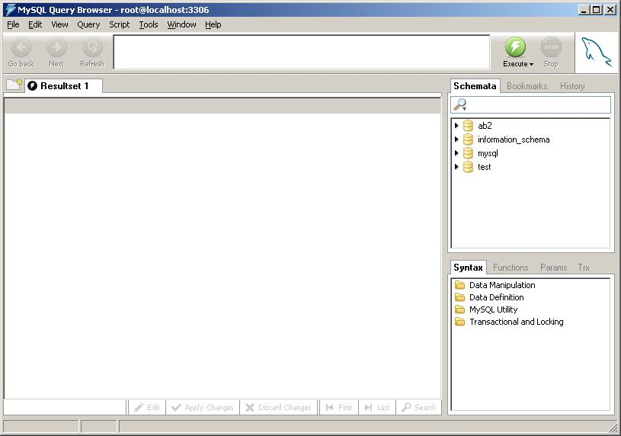

Right click in the AB2 Schemata and click “Drop Schema” and respond to the questions.

Now when you attempt to look at AB3 from a browser you should see that it reports an error saying the database “AB2” can not be found

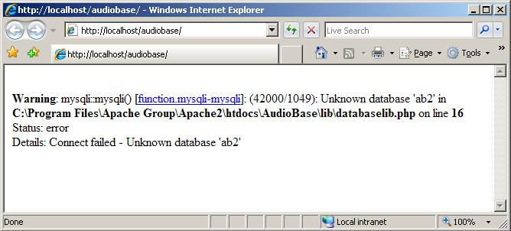

Now we need to re-create a blank database ….

Open the MySQL Command Line Client here…
START->MySQL->MySQL Server 5.0->MySQL Command Line Client

Enter the same password you used before and you should see this…

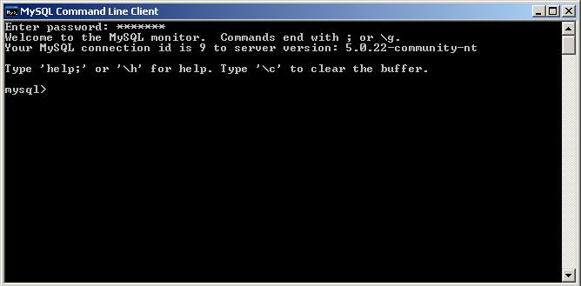

Now open the folder “My Documents/AUDIObASE 3 SQL” and then finally open the document called “AB3_MYSQL.sql”, open with Notepad, once you can see all the text type “Control A” and all the text should invert like so…

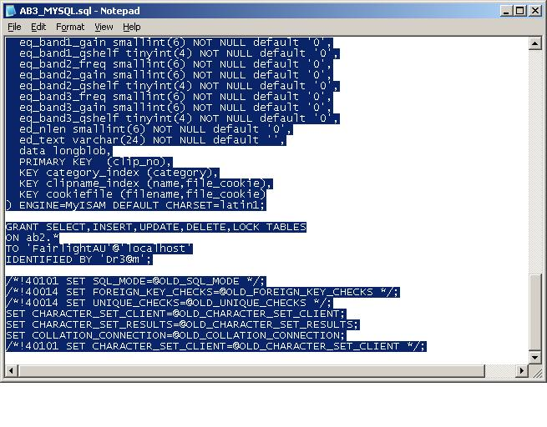
From the “Edit” menu now select “Copy”. This will copy all the selected text on to the clipboard.

We now need to paste this data back onto the “Black” DOS window we have open like so…
Click on the small icon in the top right of the “DOS” window until you see this…

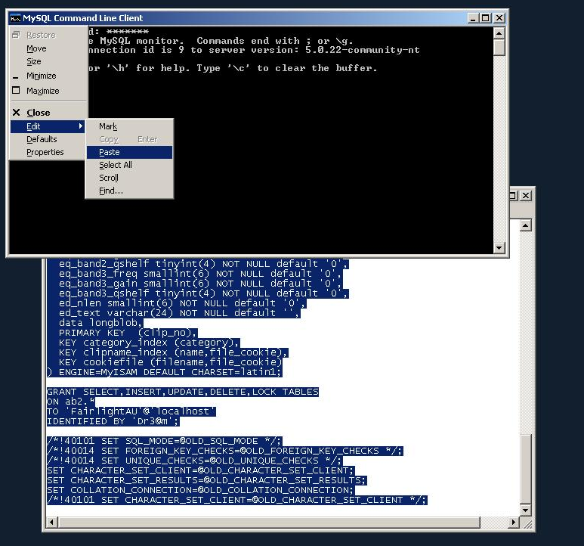

Then select “Paste”

Once the data is pasted, it will take about 5-10 seconds, you should see this… type “exit” and then “Enter”.

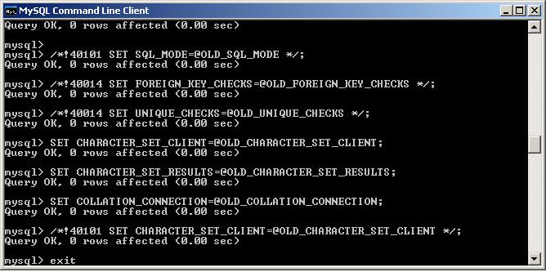

You now have a “Virgin Database”, pointing a browser to the database and doing a wild card search will now display 0 clips like so…

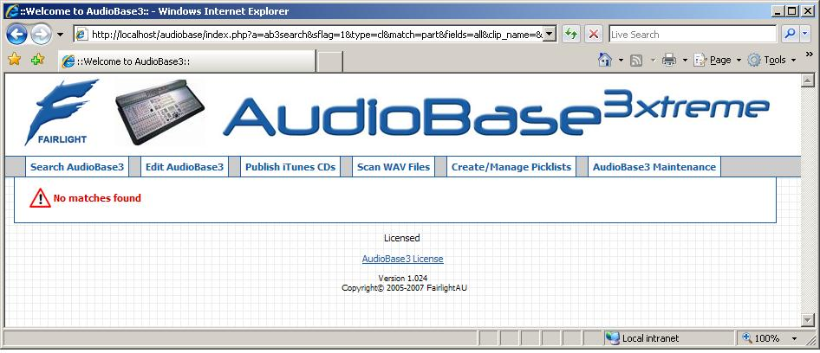

Finally you need to go to the Scan WAV files tab and follow instructions to re-scan your WAV folders.

If you have published iTunes CD’s you can now re-publish your iTunes sounds too.

[END]

